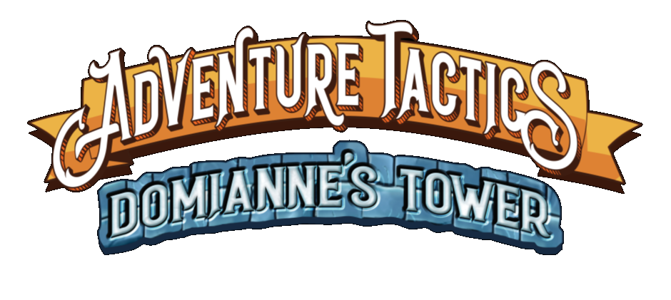
~ Clarifications / Errata ~
Heroes
Actions
- Area of Effect: AoE attacks are one roll that are applied against all targets. But if a card says "make 2 or 3 attacks," then each is treated as a separate roll.

- Discard Pile: You may search through your discard pile at any time.

- Free Actions: Free actions are still considered “actions” even though they do not count towards your 2 actions per turn limit. This is relevant to cards like “True Sigh”, “Divine Will”, and “Boon Companion”.

- Range vs Movement: Range allows diagonals, movement is orthogonal only.

- Reveal: If you are instructed to reveal the top card (e.g. The Magic Blade’s “Soul Sword”), if you are not instructed to discard it, it is placed back on top of your draw deck.

- Second Attack: If the target dies from your first attack, the second attack is optional and does not have to be performed.

- Weapon: These do not modify your basic attack value. The equipment card is used as one of your actions.

Action Cards
- Consecrated Ground: If a passive increases the damage or healing, this applies to both effects.

- Divine Lance: The trigger is: "When an enemy moves in range ..."

- Divine Shield: Only effects a single target.

- Dodge: The trigger is “When you are attacked ...”

- Flame Brand: This brand remains on until the weapon is used, but then it needs to be re-applied.

- Frost Brand: This brand remains on until the weapon is used, but then it needs to be re-applied.

- Rock Toss: The push effect is defined as moving away from the source of the push in terms of the target moving a square further away (not closer or an equal distance to the current square). The target can be moved diagonally.

- Stick and Move: This results in Move -> Attack -> Move -> Attack.

- Thunder Brand: This brand remains on until the weapon is used, but then it needs to be re-applied.

- Two as One: The 2 options do not have to match and either can be selected.

Class Features
- Shake It Off: The heal effect from this class feature can only be activated after you have resolved damage. This means that if the hero has been reduced to 0 and is knocked out, they cannot use this card.

Dice Passives
- Dice Passive Clarifications:
  - Adrenaline Rush: The dice from this does not transfer to the next encounter if not used.

  - Ancestor’s Favor: The dice from this does not transfer to the next encounter if not used.

  - Backstab: The additional die is only added to attacks.

  - Divine Destiny: The dice from this does not transfer to the next encounter if not used.

  - Divine Favor: The dice from this does not transfer to the next encounter if not used.

  - Eye for an Eye: The dice from this does not transfer to the next encounter if not used.

  - Favor of the King: The dice from this does not transfer to the next encounter if not used.

Items
- Revive Potions:
  - The “4 cards in your deck” check refers to all of your cards, e.g. hand, deck, discard pile, equipped items and class features.

  - It is optional to use a revive potion and leave a hero knocked out (and potentially be bought back with normal healing abilities), however if you have no revive potions left and a hero is then knocked out, you lose immediately.

- Unclaimed Loot: This refers to any items that were not selected.

Passives
- Duplicate Passives: It is possible to gain the same passive card twice (e.g. Tough). If both are selected, then their effect stacks.

- Passive Clarifications:
  - Beast Companion: Your Beast Companion’s action is not based on what you have selected. E.g. if you make a Basic Move, it can make a Basic Attack. The range of the Beast Companion matches your elite class, which means that if you’re a Ranger, the Beast Companion has range 2-5.

  - Divine Will: The +1 range changes the range component, not the AoE size. When paired with cards like Consecrate Ground, it allows you to move the starting target space for the AoE.

  - Guidance: The movement from Guidance is orthogonal.

  - Lone Wolf: This card specifically states “basic move card” which means that it does not trigger on basic moves that are granted from other cards.

  - Reaping Blow: This counts as an action in the same way as discarding a card to make a half basic move counts as one of your actions for the turn.

Perks
- Any of the Perks that tell you to receive a Passive or Dice Ability can be set aside. They just tell you where to get the necessary perk and are not added to your deck as dead cards.

- The Leader perk is an Action Card that goes in your deck. As a group, you decide who gets it, and then it goes into their deck.

Enemies
Activation
- Enemy Activation: Only the enemies stated on the boss card will activate. If an enemy types is not stated, it will not activate during that particular boss turn.

- Enemy Behaviour: By default, enemies will move towards the nearest hero until they are in range and use their basic attack. If they can move to a square that does allows them to attack, they will prioritise that, however it is . Some enemies will have specific behavior that can override this default behaviour such as that they will move away if they can while still staying in range, but this is not default behavior.

- Enemy Friendly-Fire: Sometimes AI enemies will blow each other up. Some enemies are immune to each other's attacks, in which case it's okay if they get caught in the blast. Enemies are very bloodthirsty, so they don't mind hitting an ally if it means maximizing their damage on heroes!

- Enemy Optimisation: Enemies move until they are in range and attack. The Campaign Guide tells you how they attack (i.e. targets closest hero, targets hero with most/least HP). If a character has AoE, it would either:
  - Emanate from themselves
  - Be described under their behavior
  - Their Boss Card would say something like “ENEMY X moves to where they can affect the most heroes with Mind Blast and uses Mind Blast.

- Enemy Order: When an enemy is activated, the enemies of that type are resolved in a player chosen order. Each enemy is fully resolved before moving to the next.

- Range: If an enemy is said to have a range of 4, this indicates 1-4.

Bosses
- Jia-Ming:
  - The Flurry ability in centred on Jia-Ming and is not a ranged attack.

- Lady Vinleskya:
  - Black Ooze: This ability has endless range from Lady Vinleskya in the orthogonal (+) or diagonal (X) pattern and does not stop even if it touches a hero.

  - Ooze: These are also referred to as Sludge Minions.

  - Sentient Ooze: The encounter mentions that slimes go before her in the initiative, however this is still controlled via the boss deck, so when Sentient Ooze is drawn, they only attack twice total.

- Loklan the Trapmaster:
  - Disarm: There are some ways to look at the top of the Boss Deck. If you don't like the trap that is about to come up, you can use the disarm action to delay that card from coming up.

  - Fire Trap: You will only take 1 white die of damage (they do not stack) and it only effects those character who are adjacent to someone else who is standing on a Fire Trap.

Line of Sight
Blue = X, Y, and Z are heroes
Red = A, B, C, D, E, F, G, H, and I are enemies
Figure 1: Line of Sight Examples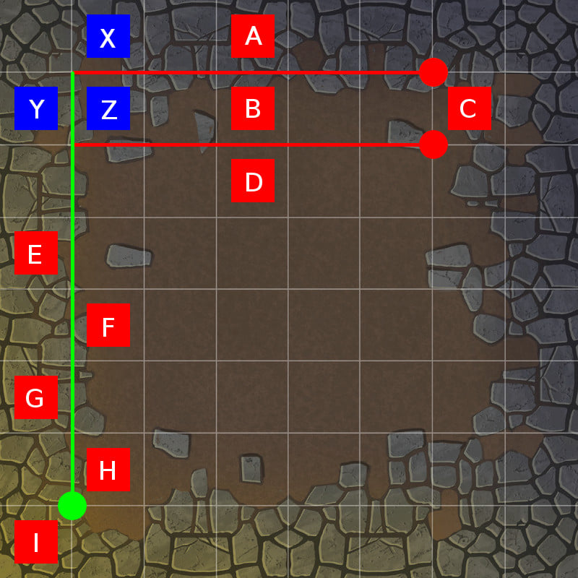
- Heroes X, Y and Z can see all enemies except C
- Enemy A can see all heroes except Y
- Enemies B, C, and D can see all heroes
- Enemies E, G, and I can see all heroes
- Enemies F and, H can see all heroes

Figure 2: More examples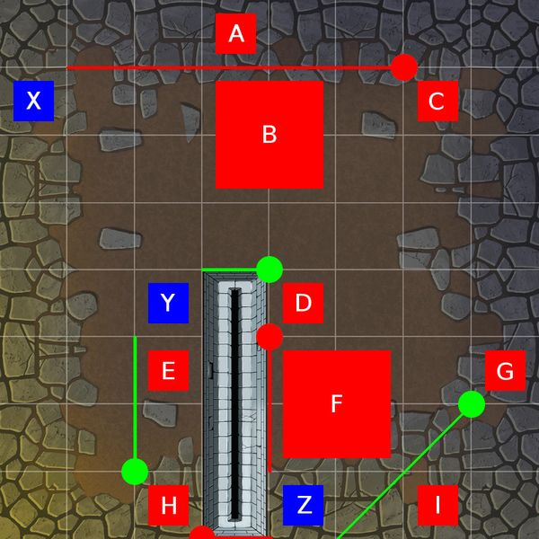

Blue = X, Y, and Z are heroes
Red = A, B, C, D, E, F, G, H, and I are enemies
- Hero X can see enemies A, B, D, E, G, and H
- Hero Y can see enemies A, B, C, D, E, and H
- Hero Z can see enemies F, G, and I
- Enemies A, B, C, D can see all heroes.
- Enemies E and H can see heroes X and Y
- Enemies F, G, and I can see heroes X and Z

MISCELLANEOUS
Cleanup
- The only conditions removed as part of this are:
  - Slowed
  - Weakened
  - Stunned
  - Invisible

Market Phase
- During this phase you may perform any 1 action for the listed price, and you can perform as many actions (different or same) that you have enough money to purchase.

Push
- Push is defined as moving away from the source of the push in terms of the target moving a square further away (not closer or an equal distance to the current square).

Random Encounters
- Damage: If you are damaged by a random encounter card, this will carry into your next encounter.

Easy to Miss rules
Action Cards
- Equipment/Class Features:
  - Any equipment or class features can be played direction from your hand without first equipping or preparing them. Once played, these will go to the discard pile (or removed if they had the Remove icon).
  - Any equipped item or prepared class feature can be played from your player board as an action. After playing any of these card, place them in your discard pile (or removed if they had the Remove icon).

- Summons: These are only considered heroes for the purposes of targeting and attacks.

- Response: Only a single Response card can be played for each event.

Leveling Up
- +/- Symbol: This indicates that when you level up, you can add one basic move or basic attack and/or permanently cull a card from your deck.

- Elite Class: If you take a level in any elite class, you must change to that elite class. If you take another level in an elite class you were previously, you will switch back to that elite class.

Corrections
Action Cards
- Damage Shield: The range of this should be 0-5.

- Side Step: There should only be 1 copy of the Action Card of Side Step (used as part of Rogue starter. The other 4 copies are not used.

Bosses
- Rigby:
  - Boss Deck says "Gang Member" instead of "Goblin Minion", and "Gang Archer" instead of "Goblin Archer".

- Loklan the Trapmaster:
  - The text is correct in regards to his range.

- Wraith:
  - Boss Deck says "Goblin Harasser" instead of "Goblin Minion", and "Goblin Champion" instead of "Hobgoblin Champion".
  - The Campaign Guide and the “Wraith Pursuit” Encounter card use the terms “Child of Light” and “Child of Destiny”. These are the same thing.

Campaign Guide
- Section 13: If you do not have the note, then you should read section 8 on page 14 and then directly proceed to the CONFRONT LORD VENTISS encounter.

Class Guide
- Skirmisher: The class requirements are incorrect and should be Rogue 1, Archer 1.

